Q1)
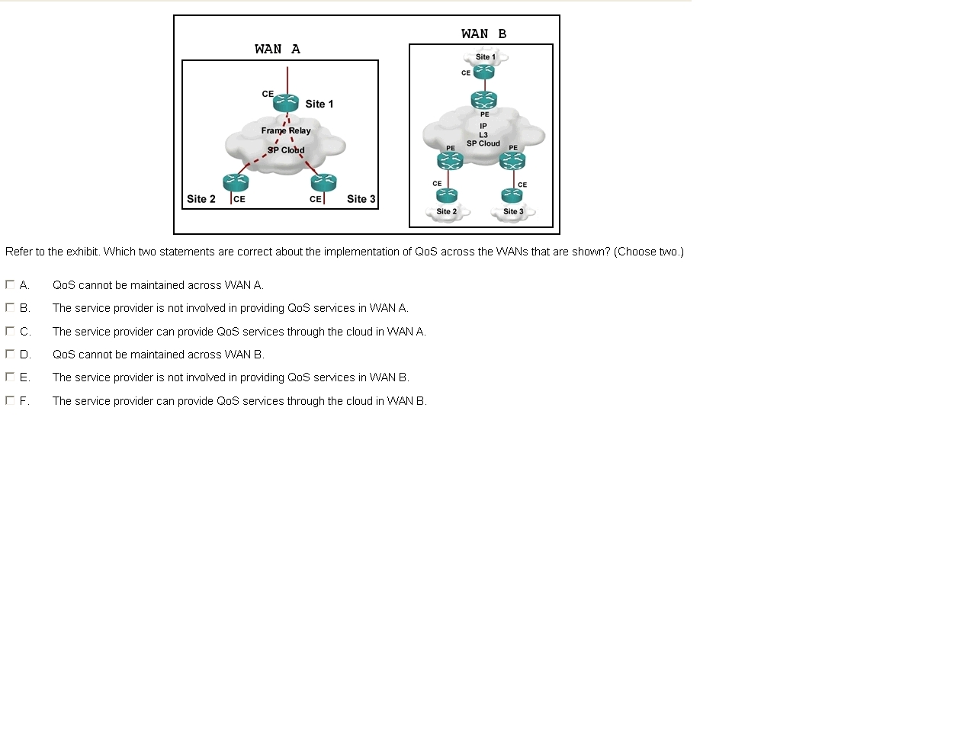
Answers: B, F

Q2)
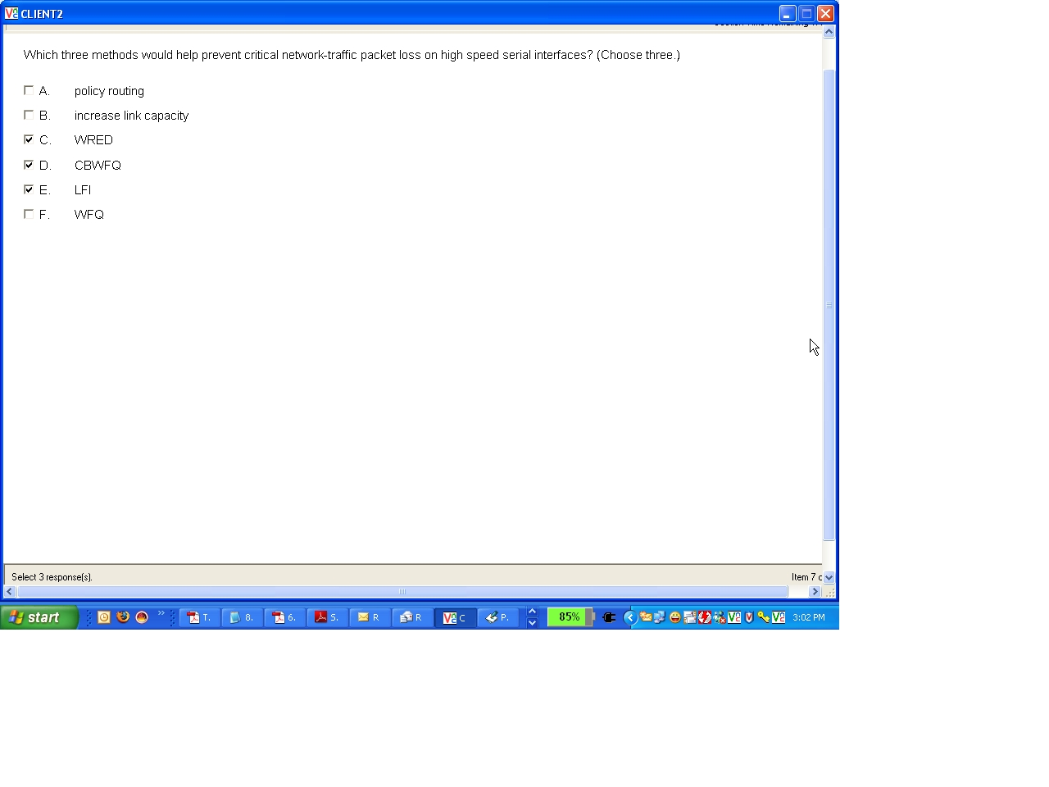
Answers: B, C, D

Q3)
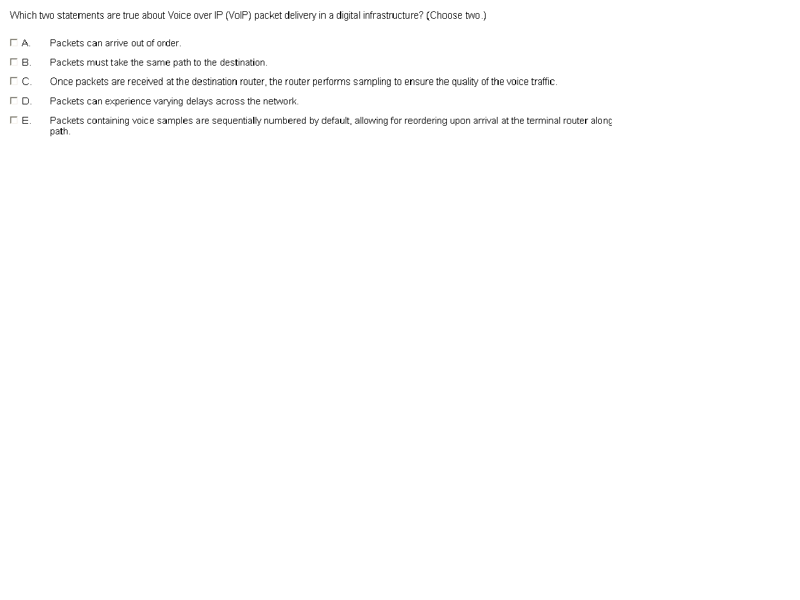
Answers: A, D

Q4)
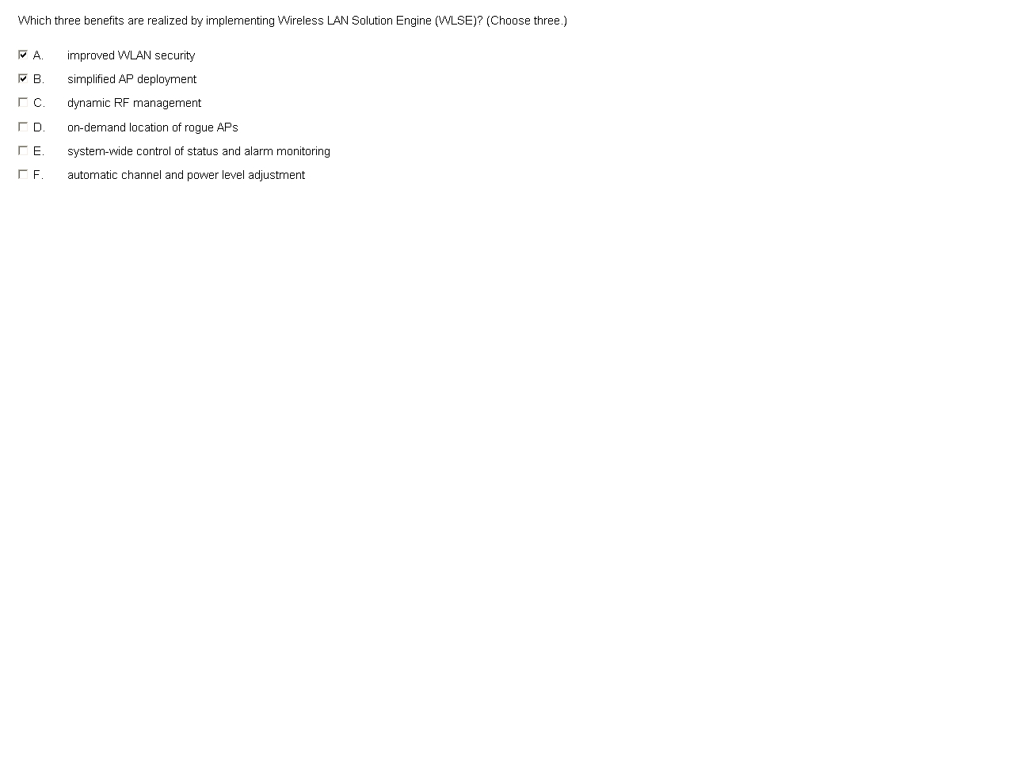
Answers: A, B, C

Q5)
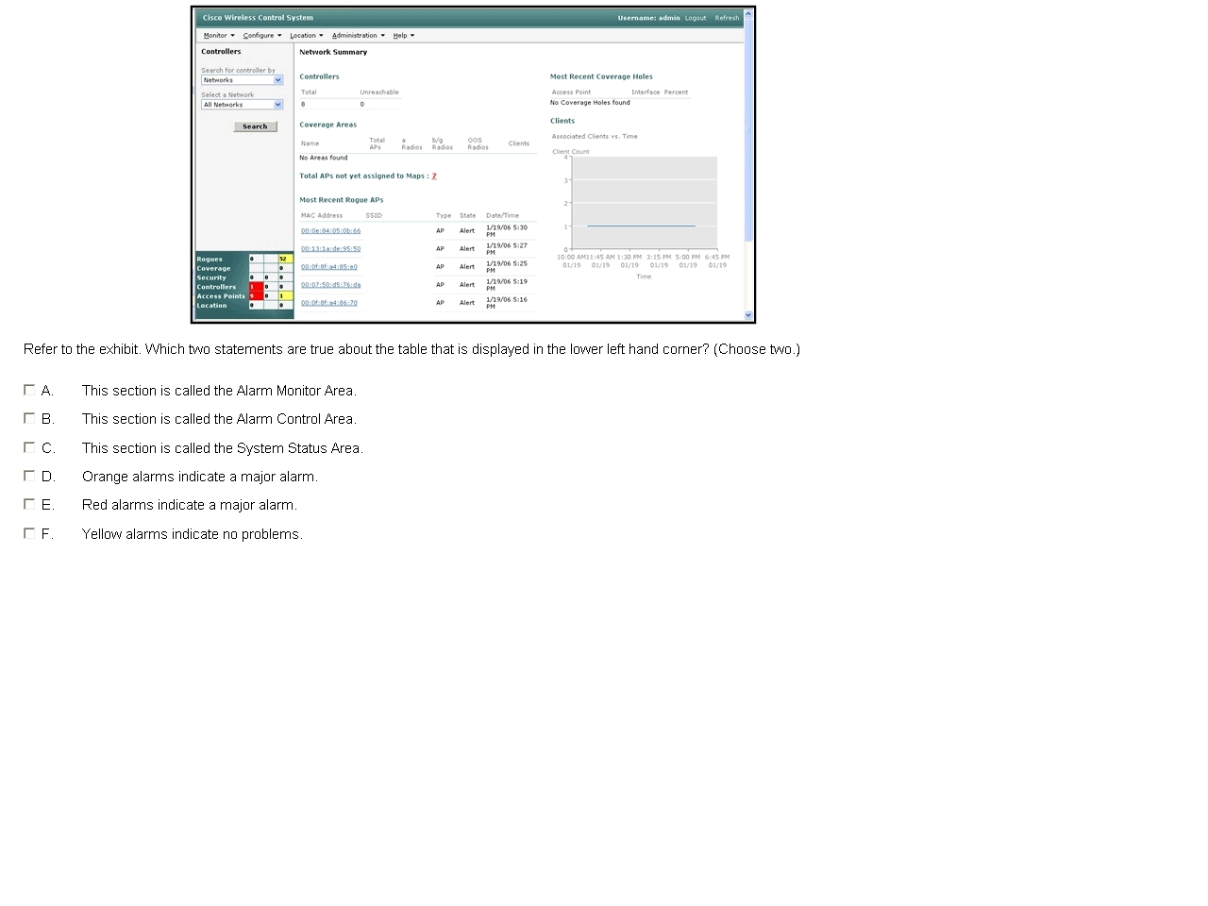
Answers: A, D

Q6)
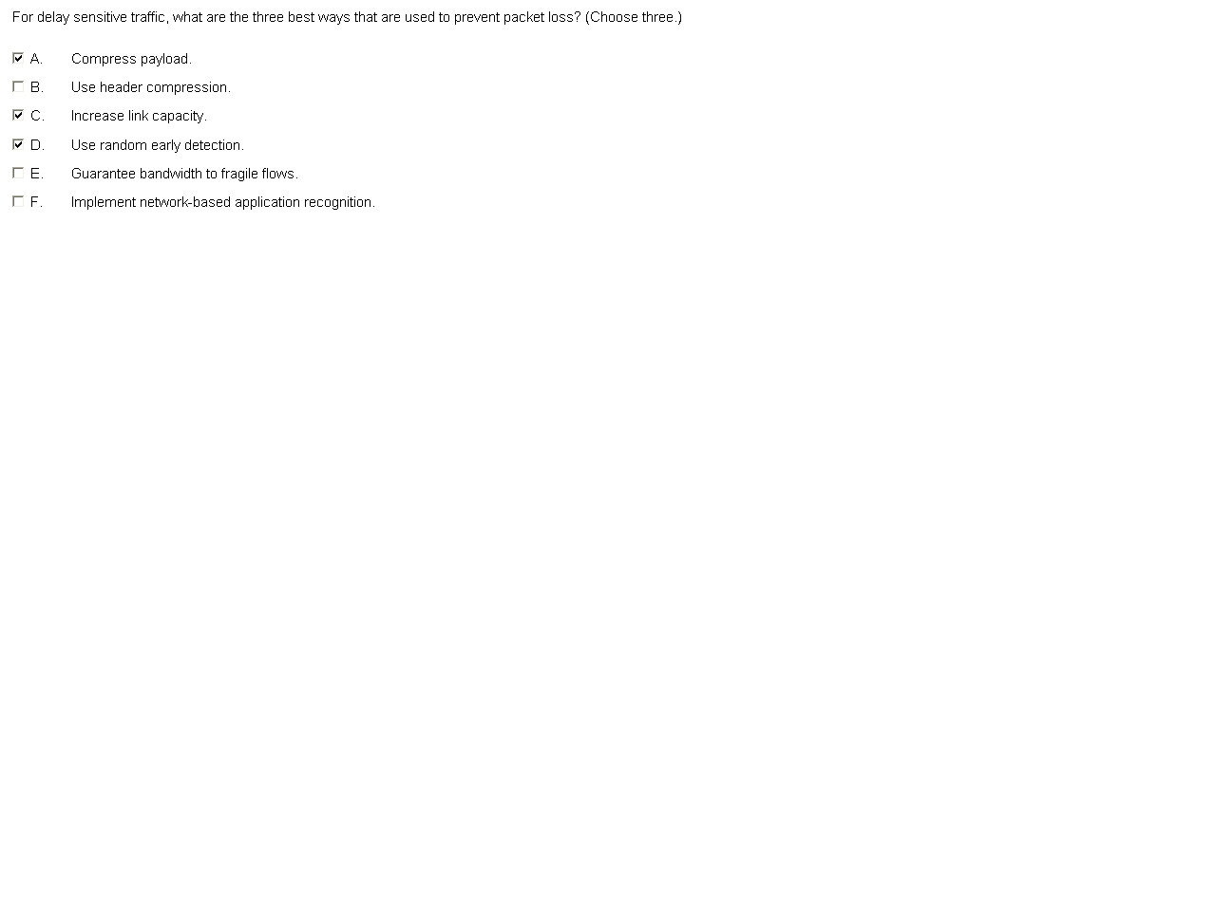
Answers: C, D, E

Q7)
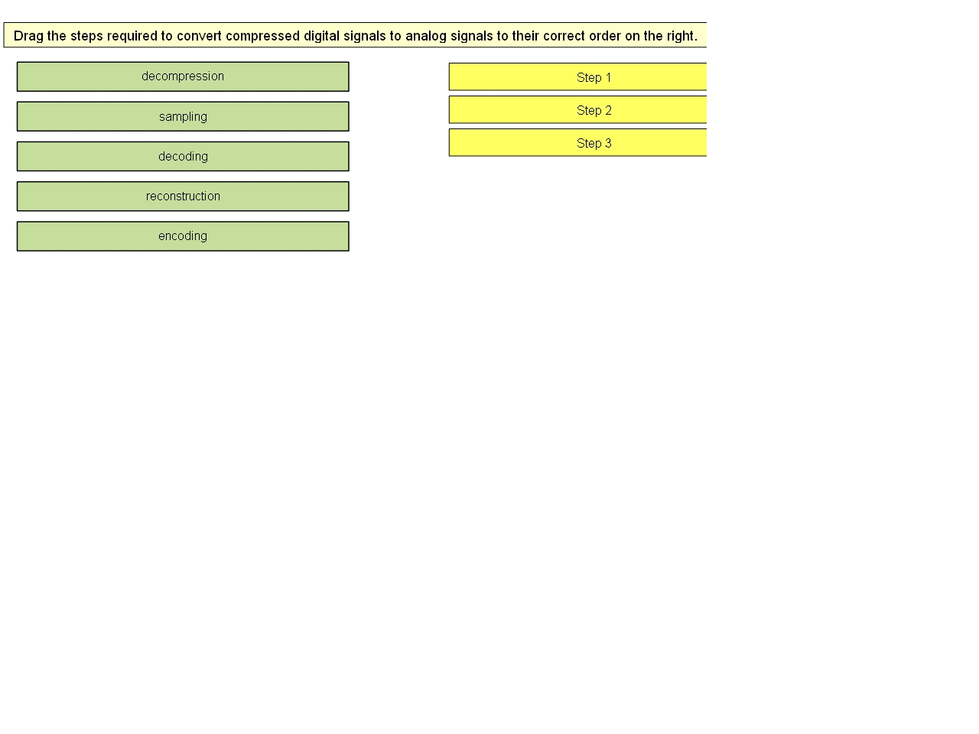
Answers, in the order: Decompression, Decoding, Reconstruction

Q8)
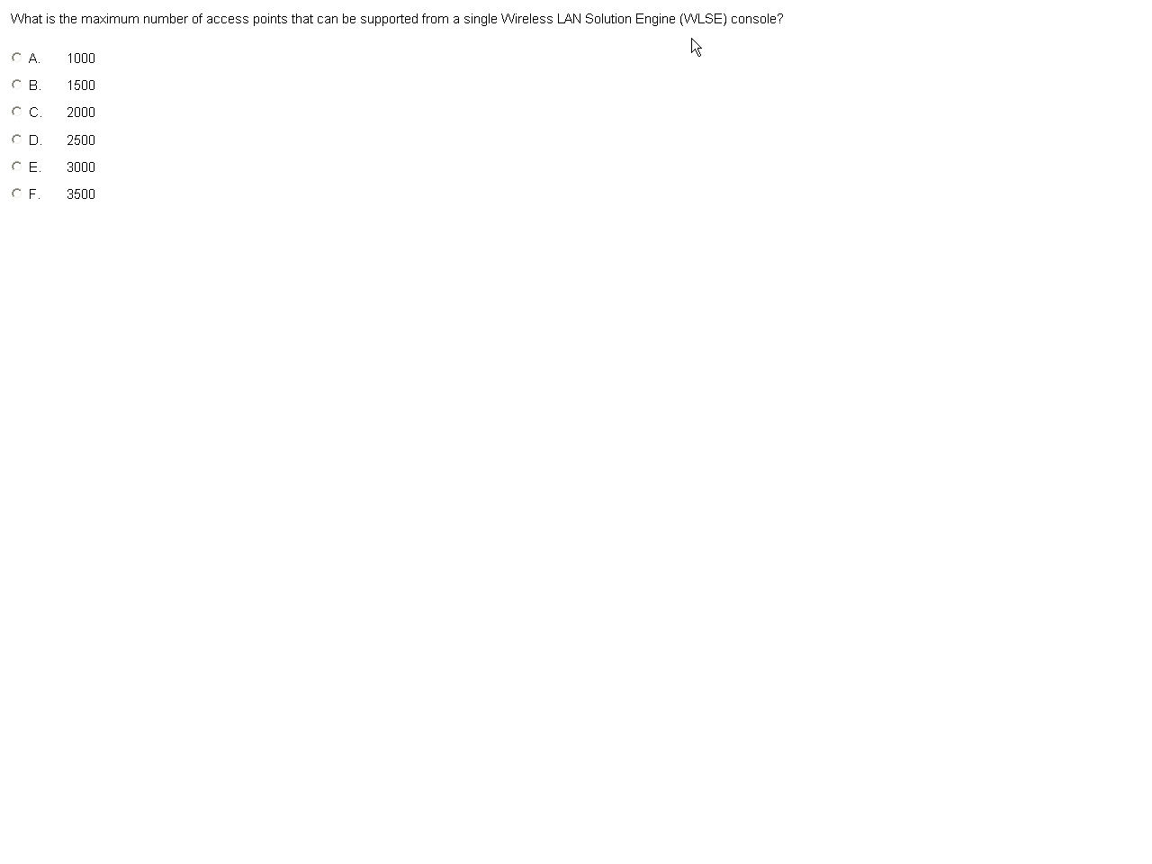
Answer: D

Q9)
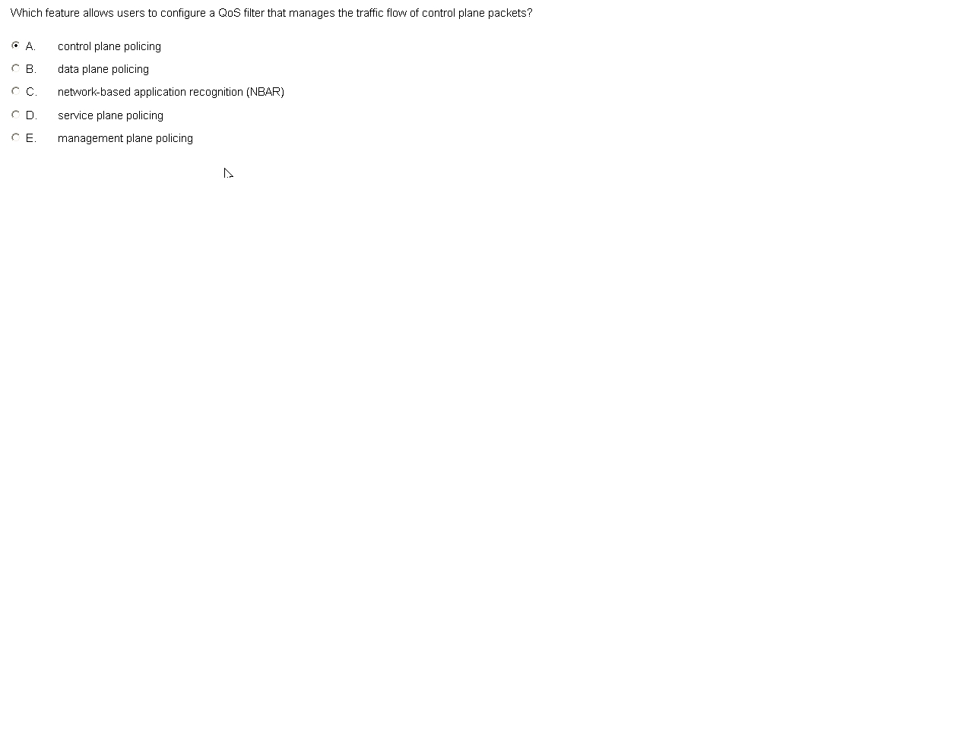
Answer: A

Q10)
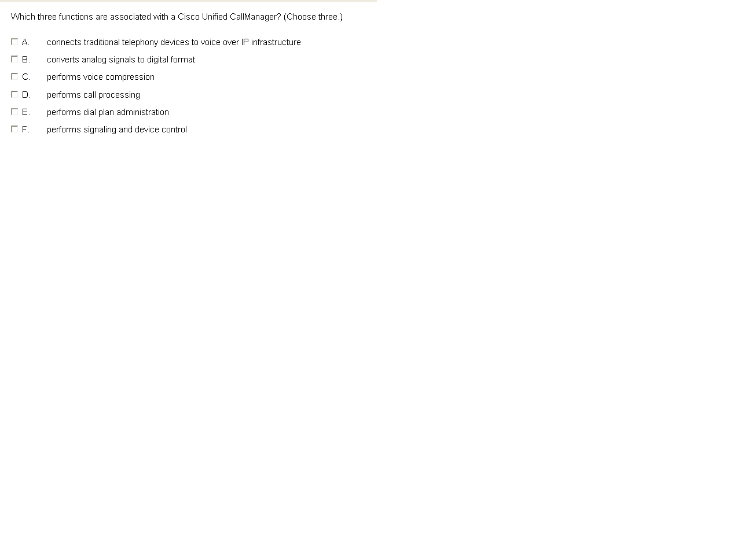
Answer: D, E, F
Ref: Student Guide V1 | P2-71

Q11)
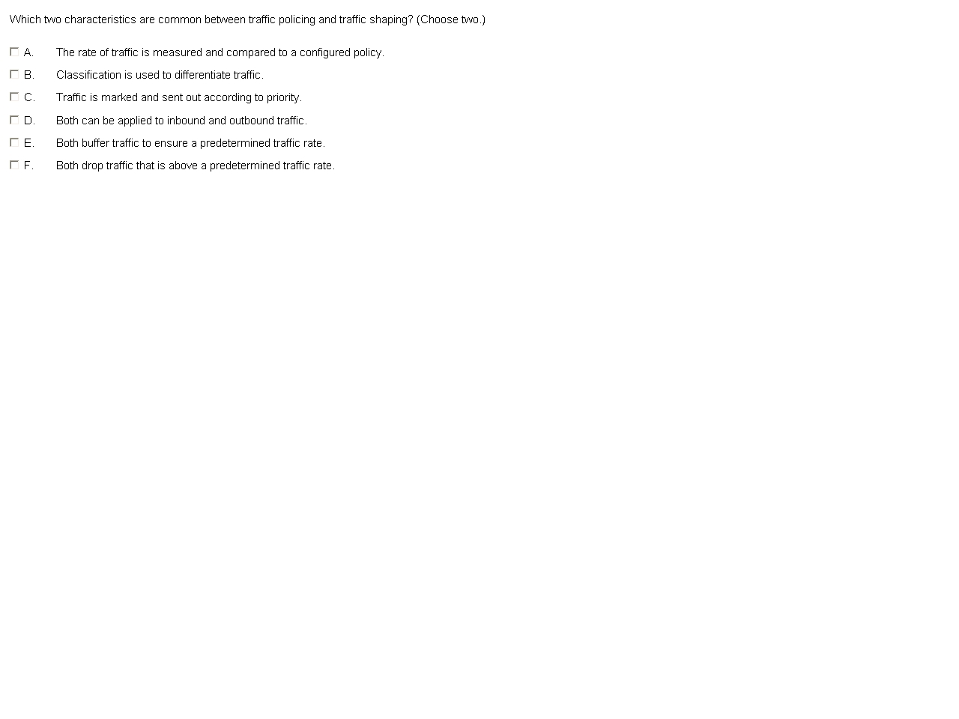
Answers: A, B

Q12
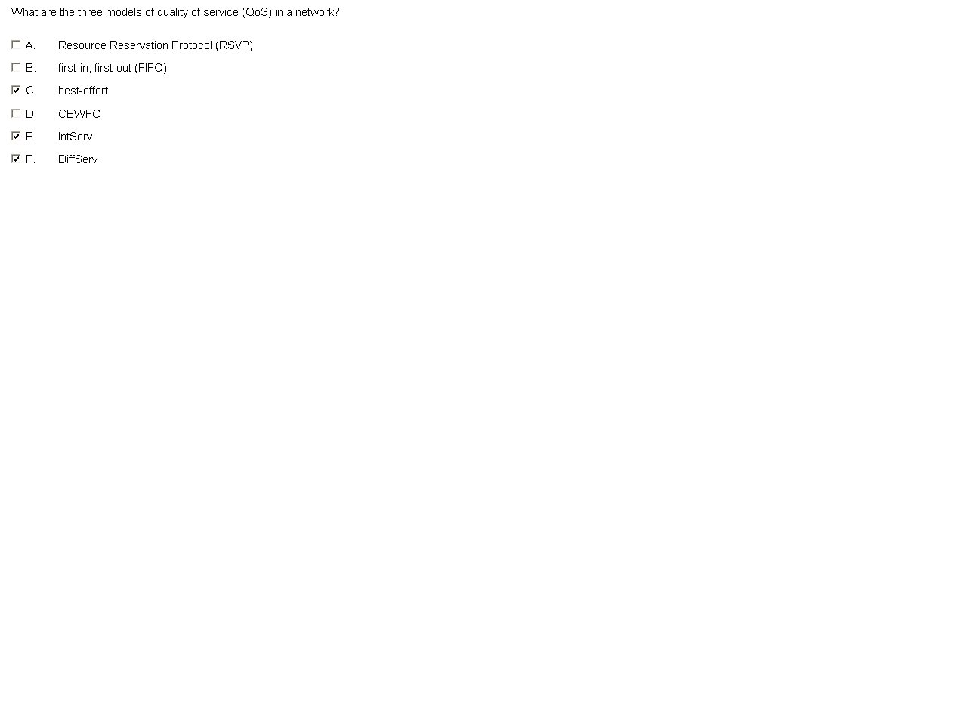
Answer: C, E, F

Q13
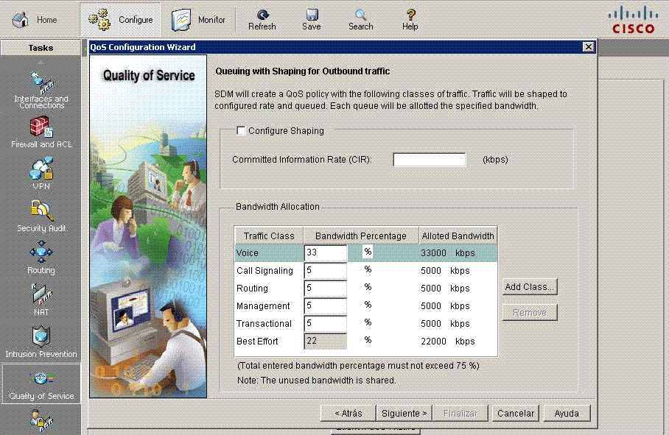
Cisco SDM is used to generate QoS policy; various QoS classes will be created and assigned a percentage of the interface bandwidth. Which three statements include the default values that are assigned by SDM for outgoing traffic on WAN interface?
A- Voice traffic will be assigned 47%of the interface bandwidth.
B- Voice call signaling will be assigned 33% of the interface bandwidth
C- Telnet, ssh and other traffic that is generated to manage the routing is assigned 5% of the interface bandwidth
D- Best effort traffic will be assigned 38% of the interface bandwidth
E- Routing protection traffic will be assigned 5% of the interface bandwidth
F- Transactional traffic will be assigned 5% of the interface bandwidth
Answers: C, E & F
Q14-What is the term that is used to describe the process of converting a signal from digital to analog.
A- Packetization
B- Quantization
C- Decoding
D- Sampling
Answers: C

Q15-In the design of the QoS which two factors should be taken into consideration?
A- On congested links, all form of traffic will require some form of QoS
B- All traffic types and requirement should be announced to determine the number of traffic classification
C- In the implementation of link efficiency mechanism on links that typically transport relatively large packets ,header compression will be most effective
D- In the implementation of link efficiency mechanism on links that typically transport relatively small packets ,header compression will be most effective
E- In the implementation of link efficiency mechanism on links that typically transport relatively small packets ,payload compression will be most effective
F- payload compression provides more available bandwidth and reduces processing delay time
Answers: B, D

Q16-The question says to transmit 1500 byte=1500*8 bit=12000 bit
the formula is Bc=CIR*Tc; Bc is measured in bit
1) CIR=1536 Kb/s, Tc=100ms
2) CIR=1536 Kb/s, Tc=10ms
3) CIR=1536 Kb/s, Tc=1ms
4) CIR=512 Mb/s, Tc=100ms
5) CIR=512 Kb/s, Tc=10ms
6) CIR=512 Kb/s, Tc=1ms
1) Bc=1536*10^3 *100*10^(-3)=153600 > 12000 bit ok
2) Bc=1536*10^3 *10*10^(-3) =15360 > 12000 bit ok
3) Bc=1536*10^3 *1*10^(-3) =1536 < 12000 bit not ok
4) Bc=512*10^6 *100*10^(-3) =51200000 > 12000 bit ok
5) Bc=512*10^3 *10*10^(-3) = 5120 < 12000 bit not ok
6) Bc=512*10^3 *1*10^(-3) = 512 < 12000 bit not ok
therefore 1), 2), 4) is right

Q17-There is a figure like page 236 official exam certification guide book and the question is:
Where occurs LWAPP encapsulation?
A- Between wireless client and wireless AP
B- Between LAN controller (WLC) and wired switch
C- Between wireless AP and wireless LAN controller (WLC)
D- Other between...
E- Other between...
Answer: C

Q18-Simlet
(1) The mission critical traffic in WAN_1 -> SQLNET
(2) Issue on WAN_2 -> Wrong policy configuration (the correct policy should be policy 1)
(3) Is FTP being marked correctly -> Yes ftp is marked correctly based on NBAR
(4) The af21 -> Citrix

Q19- About the default utilization of Lightweight Access Point.
A. 100%
B. 75 %
C. 50 %
D. None
Answer: A 100%

Q20- The exhibit shows the network summary page of a WCS.
Answers: (You can get it from the table right in the bottom)

There are 189 critical alerts concerning security
There are 623 major alerts concerning rouge APs

Q21- Question shows a WLC exhibit
A- Remove lightweight AP <------------------- wrong
B- Add (configure) new lightweight AP <- -- correct
C- ?
D- Locate (shows / detect) rogue AP <----- correct
E- Shows Mac address from rogue AP <--- correct
F- Remove rogue AP <-------------------------- wrong

Answer: B, D and E
B- Add new lightweight access point
D-Locate rouge access point
E- Show Mac address from rouge access point

Q22- How much bandwidth can be saved when using G7.29 with cRTP on Frame Relay link with a header of 6 bytes.

A- 55 %
B- 58 %
C- 60 %
D -63 %

Answer: B

Q23- There was 4 routers A, B, C, and D connected with frame relay cloud. The question was where to apply inbound and outbound policy (choose two)
Answers...

*inbound at remote site
*outbound at central site

Q24- An exhibit showing 3 Remote sites B, C, and D connected to a Central Site A via a Frame Relay Connection. Links A, B, C & D are T1, 128k, 512k and 768k respectively. Refer to the exhibit. Which two points would traffic shaping and traffic policing best is applied? (Choose 2)
A- Central Site – apply traffic shaping inbound so that the central router and servers will not experience congestion.
B- Central Site – apply traffic policing outbound so that the link speed will match the link speed of the remote sites.
C- Remote Site – apply traffic shaping inbound so that the traffic coming from the central site does not cause congestion in the remote network.
D- Remote Site – apply traffic shaping outbound so that the remote links are not oversubscribed.
E-Remote Site – apply traffic shaping outbound so that packets are priority and packets that are received in excess are dropped.

Answers: B, C

Q25- WMM, which says if a packet that is destined for no one of the 4 categories
(Best effort, Background, Voice, Video) then it will be categorized as which category?
The correct answer is best effort.

Gold=Voice
Platinum=video
Silver=Scavenger
Bronze=Best Effort

This is wrong (Platinum should be voice, gold should be video, silver should be best effort, bronze should be scavenger),

The right answer is: WMM will apply all unmarked traffic with default Best Effort Access Category

Q26- What payload compression does?
A- Compress entire layer 2 frame
B- Compress entire layer 3 ip packet
Answer is B.
Exp: Payload compression is mostly performed on Layer 2 frames and, as a result, compresses the entire Layer 3 packet

Q27- Question about how or where to apply rules in Copp (choose 3)
A. Apply inbound only
B. Apply outbound only
C. Established on ingress and egress
D. After control plane.......
E. Before control plane......
F. Exist control plane.......
Answer is A, C & E

COPP - control plane policy
-rules are applied to the INGRESS AND EGRESS.
-the rules are Apply & before processing and when traffic exists.

Q28- Diagram of laptop(X) =======Access point(Y) =========Radius server (Z) (choose two)

1. X is supplicant Y is authenticator
2. Y is authenticator Z is radius server

Q29-Major issues and challenges when facing a converged enterprise network
The Answers Are:
* Available Bandwidth
*End-End Delay (Delay Variation)
*Packet-Loss (Reliability)

Q30-about WEP (select 2)
A- 24
B- 40
C- 80
D- 128
E- 160
Answers: B, D

Q31- Max compression limit -> choices were Shannon’s limit, Huffman’s limit etc.
Answer: Shannon’s limit.

Q32-There was a question for VPN QoS and asked which protocol will be applied for AH and ESP.
Answer:
Protocol AH: 51
Protocol ESP: 50

Q33-Choose three responses (out of 6) of how WCS re-acts when a rouge AP enters the network:
Answer:
Rogue Access Point Detection
Rogue Access Point Alarms
Rogue Access Point Location

Q34-Asking about the correct order of 3 steps involved in conversion of a compressed digital voice packet to analog Voice
Answers:
1) Decompressing
2) Decoding
3) Reconstruction

Q35- Asking about the protection of routers and switches from DoS attack (Answer options were different from p4s)
Answer Control Plane Policing"

Q36- Can you configure Qos from SDM menus?
Answer --Quality of Services menu

Q37- What need you configure AutoQos? (Select three options)
- Bandwidth quantity 2. ? 3?

Q38-What does FIFO use?
A-Hardware
B- Software
C- Hardware and software
Answer: C

Q39- About NBAR I remember the answer it was multiple choice with 2 selections:

- NBAR detect UPD and TCP
- PDLM can be customized for the special applications

Q40- Question showed a SDM screenshot and was asking to select one 1 option out of 6 for showing the policy.
The correct answer for this is the Option of INTERFACE.

Q41- About wireless QOS something with these terms about QOS-Configurable profiles:
- Per user data bandwidth contract - configure peal and average data rate enforcement for non-UDP traffic
- Per user real-time bandwidth contract - configure peal and average data rate enforcement for UDP traffic

Q42- What is Processing delay
Answer: Time from input to output interface

Q43- Asking about the protection of routers and switches from DoS attack (Answer options were different from p4s)
Answer Control Plane Policing"

Q44- Which CBWFQ statement is not correct?
a. Each of the queues in CBWFQ is a FIFO queue that tail drops by default
b. CBFWQ allows creation of user-defined classes.
c. CBFWQ addresses the entire shortcoming of WFQ
d. CBFWQ allows minimum BW reservation for each queue

The right answer A it is C in p4s

To have the best possible voice quality and to utilize effectively the available bandwidth, which queuing and compression mechanisms need to be used?
(Choose two.)
A. class-based weighted fair queuing (CBWFQ)
B. low latency queuing (LLQ)
C. priority queuing (PQ) or custom queuing (CQ)
D. Real-Time Transport Protocol (RTP) header compression
E. TCP header compression
F. UDP header compression

QUOTE
Which queuing and compression mechanisms are needed to effectively use the available bandwidth for voice traffic? (Choose two.)
A. class-based weighted fair queuing (CBWFQ)
B. low latency queuing (LLQ)
C. priority queuing (PQ) or custom queuing (CQ)
D. Real-Time Transport Protocol (RTP) header compression
E. TCP header compression
F. UDP header compression

